Configuring Google Kubernetes Engine (GKE) Networking
experimentLabschedule1 houruniversal_currency_altNo costshow_chartIntroductory
infoThis lab may incorporate AI tools to support your learning.

Overview
In this lab, you will create a standard cluster which uses internal RFC 1918 IP addresses, add an authorized network for API access to it, and then configure a network policy for Pod security.
Note: For this lab, GKE Standard Mode will be used. The lab explores cluster network policies and these are enabled by default in GKE Autopilot.

Objectives
In this lab, you learn how to perform the following tasks:
- Create and test a standard cluster which uses internal RFC 1918 IP addresses.
- Configure a cluster for authorized network control plane access.
- Configure a Cluster network policy.

Setup and requirements
For each lab, you get a new Google Cloud project and set of resources for a fixed time at no cost.
- Click the Start Lab button. If you need to pay for the lab, a pop-up opens for you to select your payment method. On the left is the Lab Details panel with the following:
  - The Open Google Cloud console button
  - Time remaining
  - The temporary credentials that you must use for this lab
  - Other information, if needed, to step through this lab
- Click Open Google Cloud console (or right-click and select Open Link in Incognito Window if you are running the Chrome browser).
The lab spins up resources, and then opens another tab that shows the Sign in page.
Tip: Arrange the tabs in separate windows, side-by-side.
- Note: If you see the Choose an account dialog, click Use Another Account.
- If necessary, copy the Username below and paste it into the Sign in dialog.
- "Username"
- Copied!
- You can also find the Username in the Lab Details panel.
- Click Next.
- Copy the Password below and paste it into the Welcome dialog.
- "Password"
- Copied!
- You can also find the Password in the Lab Details panel.
- Click Next.
- Important: You must use the credentials the lab provides you. Do not use your Google Cloud account credentials.
- Note: Using your own Google Cloud account for this lab may incur extra charges.
- Click through the subsequent pages:
  - Accept the terms and conditions.
  - Do not add recovery options or two-factor authentication (because this is a temporary account).
  - Do not sign up for free trials.
After a few moments, the Google Cloud console opens in this tab.
Note: To view a menu with a list of Google Cloud products and services, click the Navigation menu at the top-left, or type the service or product name in the Search field. 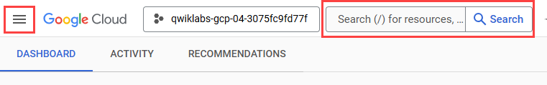
After you complete the initial sign-in steps, the project dashboard appears.

Activate Google Cloud Shell
Google Cloud Shell is a virtual machine that is loaded with development tools. It offers a persistent 5GB home directory and runs on the Google Cloud.
Google Cloud Shell provides command-line access to your Google Cloud resources.
- In Cloud console, on the top right toolbar, click the Open Cloud Shell button.
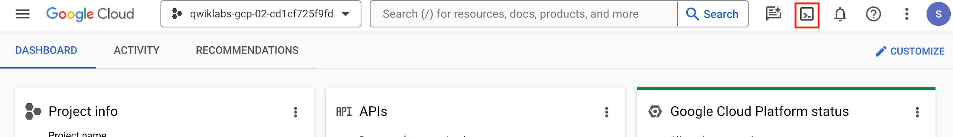
- Click Continue.
It takes a few moments to provision and connect to the environment. When you are connected, you are already authenticated, and the project is set to your PROJECT_ID. For example:
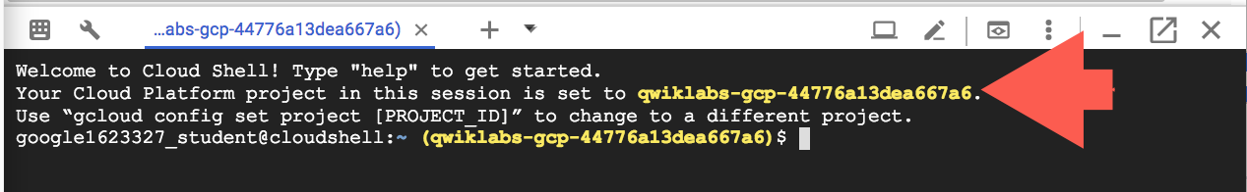
gcloud is the command-line tool for Google Cloud. It comes pre-installed on Cloud Shell and supports tab-completion.
- You can list the active account name with this command:
gcloud auth list
Copied!
Output:
Credentialed accounts:
- <myaccount>@<mydomain>.com (active)
</mydomain></myaccount>
Example output:
Credentialed accounts:
- google1623327_student@qwiklabs.net
- You can list the project ID with this command:
gcloud config list project
Copied!
Output:
[core]
project = <project_id>
</project_id>
Example output:
[core]
project = qwiklabs-gcp-44776a13dea667a6
Note: Full documentation of gcloud is available in the gcloud CLI overview guide .

Task 1. Create a standard cluster
In this task, you create a standard cluster, that uses internal RFC 1918 IP addresses.
All workers nodes in the cluster will only have internal RFC 1918 IP addresses. This ensures that their workloads are isolated from the public Internet and do not have a public IP address.

Set up a standard cluster
- In the Navigation menu (), click Kubernetes Engine > Clusters.
- Click Create then click Configure under Standard: You manage your cluster.
- Name the cluster standard-cluster.
- Select ZONE as the Zone.
- In the left pane, in Node Pools click default-pool.
- In Number of nodes type 2.
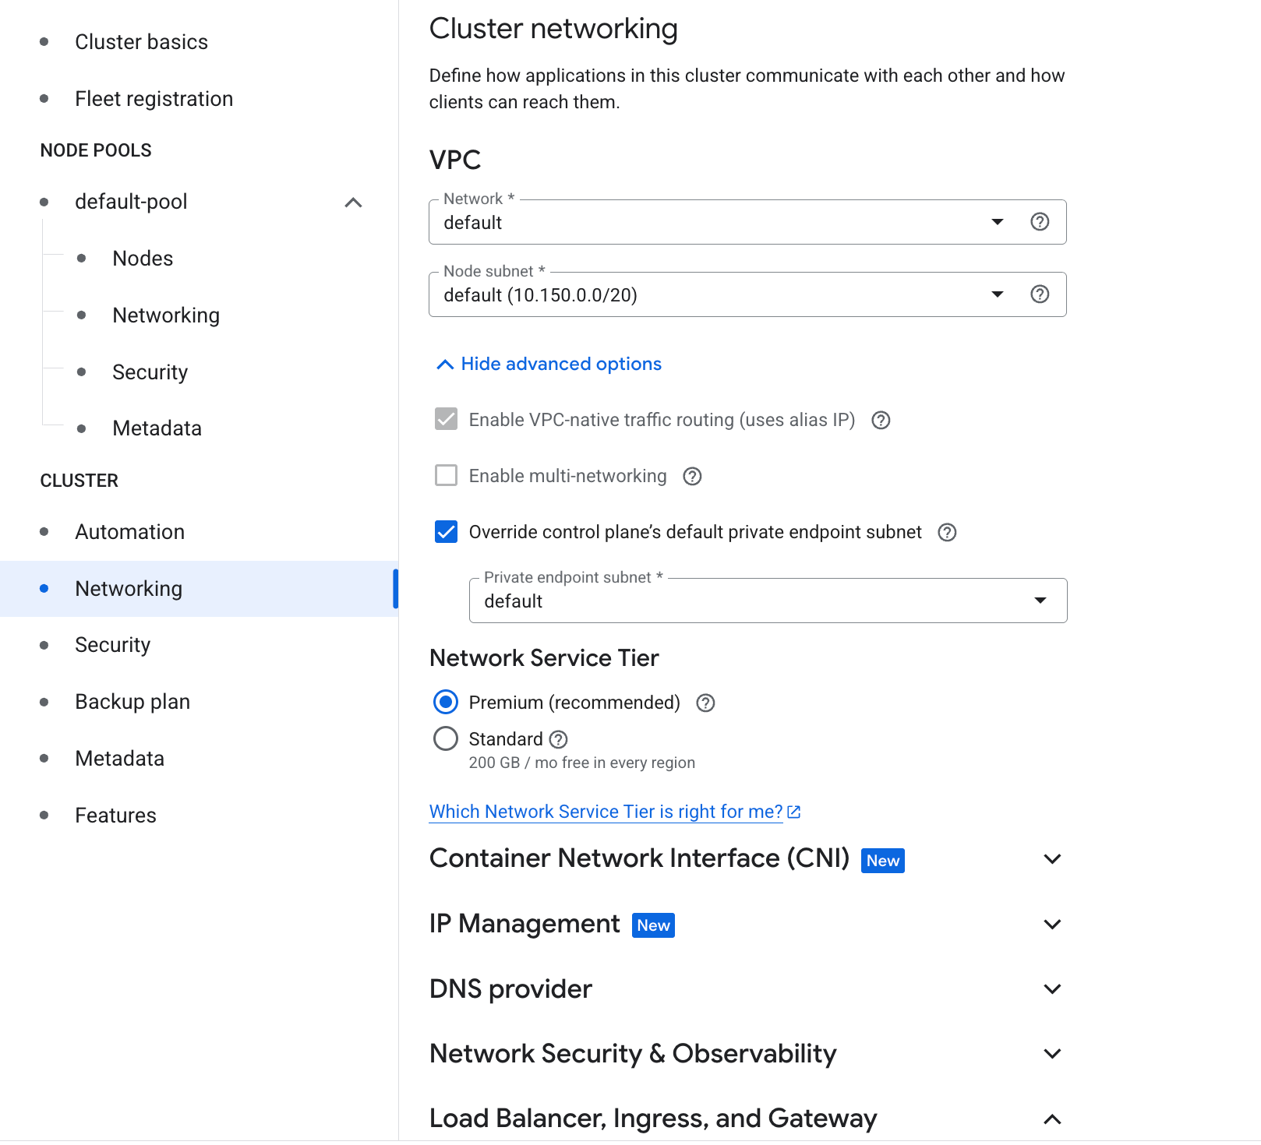
- In the left pane, in Cluster click on Networking.
- Ensure Enable authorized networks is not selected.
- Under Cluster Networking expand Show advanced options Select the checkbox to Override control plane’s default private endpoint subnet.
- For Private endpoint subnet select default.
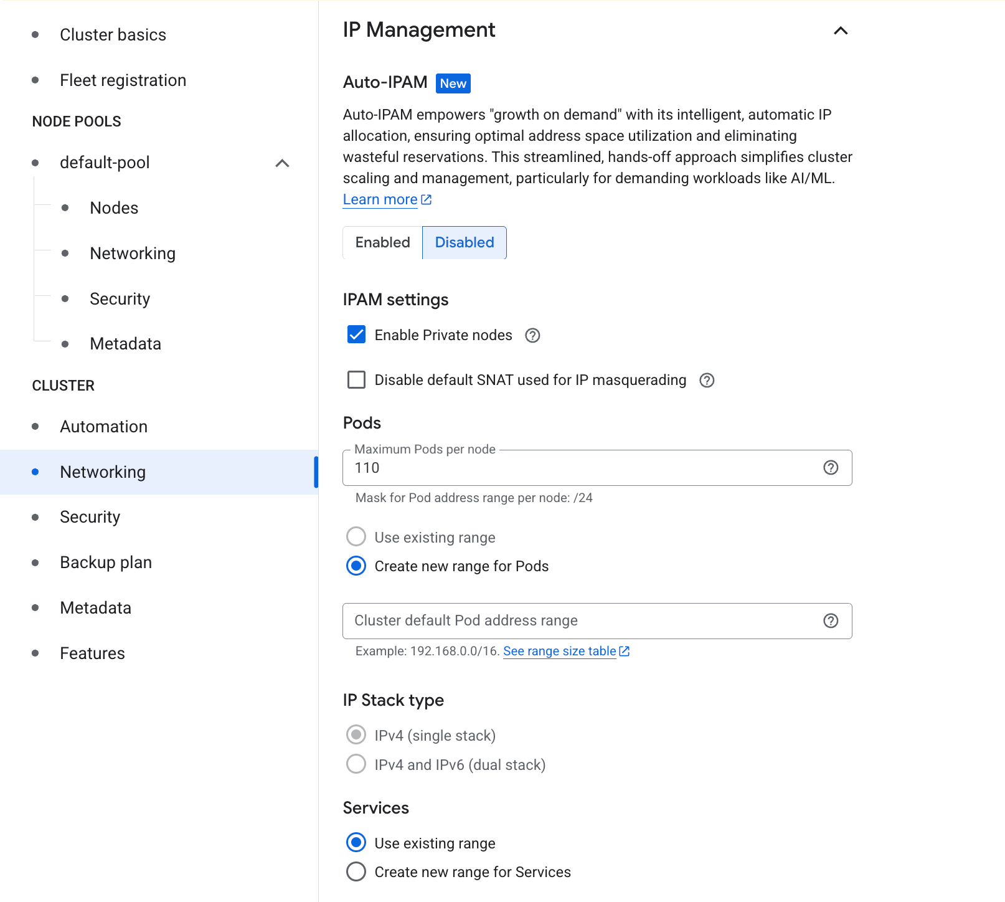
- Under IP Management Select the checkbox to Enable Private nodes.
Note: Google Cloud uses VPC peering to connect the VPC of the cluster with your default VPC network.
You may have to scroll down to see this option.
This setting allows you the range of addresses that can access the cluster externally. When this checkbox is not selected, you can access kubectl only from within the Google Cloud network. In this lab, you will only access kubectl through the Google Cloud network but you will modify this setting later.
- Click Create.
Note: You need to wait a few minutes for the cluster deployment to complete.

Inspect your cluster
- In the Cloud Shell, enter the following command to review the details of your new cluster:
gcloud container clusters describe standard-cluster --zone ZONE
Copied!
The following values appear only under the cluster:
- privateEndpoint, an internal IP address. Nodes use this internal IP address to communicate with the cluster control plane.
- publicEndpoint, an external IP address. External services and administrators can use the external IP address to communicate with the cluster control plane.
You have several options to lock down your cluster to varying degrees:
- The whole cluster can have external access.
- The whole cluster can have internal access.
- The nodes can be internal while the cluster control plane can be public, and you can limit which external networks are authorized to access the cluster control plane.
Without public IP addresses, code running on the nodes can't access the public internet unless you configure a NAT gateway such as Cloud NAT.
You might use a cluster with internal access to provide services such as internal APIs that are meant only to be accessed by resources inside your network. For example, the resources might be private tools that only your company uses. Or they might be backend services accessed by your frontend services, and perhaps only those frontend services are accessed directly by external customers or users. In such cases, these clusters are a good way to reduce the surface area of attack for your application.
Click Check my progress to verify the objective.
Create a standard cluster

Task 2. Add an authorized network for cluster control plane access
After cluster creation, you might want to issue commands to your cluster from outside Google Cloud. For example, you might decide that only your corporate network should issue commands to your cluster control plane. Unfortunately, you didn't specify the authorized network on cluster creation.
In this task, you add an authorized network for cluster control plane access.
Note: In this task, you make the Kubernetes control plane API accessible to a specific range of network addresses. In a real-world use of GKE, this connection would be used by IT staff and automated processes, not end-users.
- In the Google Cloud console Navigation menu (), click Kubernetes Engine > Clusters.
- Click standard-cluster to open the Clusters details page.
- In Details tab, under Control Plane Networking section, click on Edit().
- Select Enable authorized networks.
- Click Add an authorized network.
- For Name, type the name for the network, use Corporate.
- For Network, type a CIDR range that you want to grant allow listed access to your cluster control plane. As an example, you can use 192.168.1.0/24.
- Click Done.
- Ensure the following parameters are enabled:
  - Access using the control plane's external IP address
  - Access using the control plane's internal IP address from any region
  - Enforce authorized networks on the control plane's internal endpoint
  - Add Google Cloud external IP addresses to authorized networks
Multiple networks can be added here if necessary, but no more than 50 CIDR ranges.
Note: Outside this lab environment, a practical example might be to whitelist only the public, outside address of your corporate firewall. For example, if your corporate firewall's IP address were 8.8.8.14, you could whitelist access to 8.8.8.14/32.
- Click Save changes at the bottom of the menu.
Click Check my progress to verify the objective.
Add an authorized network for cluster control plane access

Task 3. Create a cluster network policy
In this task, you create a cluster network policy to restrict communication between the Pods. A zero-trust zone is important to prevent lateral attacks within the cluster when an intruder compromises one of the Pods.

Create a GKE cluster
- In Cloud Shell, type the following command to set the environment variable for the zone and cluster name:
export my_zone=ZONE
export my_cluster=standard-cluster-1
Copied!
- Configure kubectl tab completion in Cloud Shell:
source <(kubectl completion bash)
Copied!
- In Cloud Shell, type the following command to create a Kubernetes cluster. Note that this command adds the additional flag --enable-network-policy to the parameters you have used in previous labs. This flag allows this cluster to use cluster network policies:
gcloud container clusters create $my_cluster --num-nodes 3 --enable-ip-alias --zone $my_zone --enable-network-policy
Copied!
- In Cloud Shell, configure access to your cluster for the kubectl command-line tool, using the following command:
gcloud container clusters get-credentials $my_cluster --zone $my_zone
Copied!
- Run a simple web server application with the label app=hello, and expose the web application internally in the cluster:
kubectl run hello-web --labels app=hello \
--image=gcr.io/google-samples/hello-app:1.0 --port 8080 --expose
Copied!

Restrict incoming traffic to Pods
Let's create a sample NetworkPolicy manifest file called hello-allow-from-foo.yaml . This manifest file defines an ingress policy that allows access to Pods labeled app: hello from Pods labeled app: foo.
- Create and open a file called hello-allow-from-foo.yaml with nano using the following command:
nano hello-allow-from-foo.yaml
Copied!
- Once nano has opened, paste the following into the hello-allow-from-foo.yaml file:
kind: NetworkPolicy
apiVersion: networking.k8s.io/v1
metadata:
name: hello-allow-from-foo
spec:
policyTypes:
- Ingress
podSelector:
matchLabels:
app: hello
ingress:
- from:
- podSelector:
matchLabels:
app: foo
Copied!
- Press Ctrl+O, and then press Enter to save your edited file.
- Press Ctrl+X to exit the nano text editor.
- Create an ingress policy:
kubectl apply -f hello-allow-from-foo.yaml
Copied!
- Verify that the policy was created:
kubectl get networkpolicy
Copied!
Output:
NAME POD-SELECTOR AGE
hello-allow-from-foo app=hello 7s

Validate the ingress policy
- Run a temporary Pod called test-1 with the label app=foo and get a shell in the Pod:
kubectl run test-1 --labels app=foo --image=alpine --restart=Never --rm --stdin --tty
Copied!
Note: The kubectl switches used here in conjunction with the run command are important to note.
--stdin ( alternatively -i ) creates an interactive session attached to STDIN on the container.
--tty ( alternatively -t ) allocates a TTY for each container in the pod.
--rm instructs Kubernetes to treat this as a temporary Pod that will be removed as soon as it completes its startup task. As this is an interactive session it will be removed as soon as the user exits the session.
--label ( alternatively -l ) adds a set of labels to the pod.
--restart defines the restart policy for the Pod.
- Make a request to the hello-web:8080 endpoint to verify that the incoming traffic is allowed:
wget -qO- --timeout=2 http://hello-web:8080
Copied!
Output:
If you don't see a command prompt, try pressing enter.
/ # wget -qO- --timeout=2 http://hello-web:8080
Hello, world!
Version: 1.0.0
Hostname: hello-web-8b44b849-k96lh
/ #
- Type exit and press ENTER to leave the shell.
- Now you will run a different Pod using the same Pod name but using a label, app=other, that does not match the podSelector in the active network policy. This Pod should not have the ability to access the hello-web application.
kubectl run test-1 --labels app=other --image=alpine --restart=Never --rm --stdin --tty
Copied!
- Make a request to the hello-web:8080 endpoint to verify that the incoming traffic is not allowed:
wget -qO- --timeout=2 http://hello-web:8080
Copied!
The request times out.
Output:
If you don't see a command prompt, try pressing enter.
/ # wget -qO- --timeout=2 http://hello-web:8080
wget: download timed out
/ #
- Type exit and press ENTER to leave the shell.

Restrict outgoing traffic from the Pods
You can restrict outgoing (egress) traffic as you do incoming traffic. However, in order to query internal hostnames (such as hello-web) or external hostnames (such as www.example.com), you must allow DNS resolution in your egress network policies. DNS traffic occurs on port 53, using TCP and UDP protocols.
Let's create a NetworkPolicy manifest file foo-allow-to-hello.yaml. This file defines a policy that permits Pods with the label app: foo to communicate with Pods labeled app: hello on any port number, and allows the Pods labeled app: foo to communicate to any computer on UDP port 53, which is used for DNS resolution. Without the DNS port open, you will not be able to resolve the hostnames.
- Create and open a file called foo-allow-to-hello.yaml with nano using the following command:
nano foo-allow-to-hello.yaml
Copied!
- Once nano has opened, paste the following into the foo-allow-to-hello.yaml file:
kind: NetworkPolicy
apiVersion: networking.k8s.io/v1
metadata:
name: foo-allow-to-hello
spec:
policyTypes:
- Egress
podSelector:
matchLabels:
app: foo
egress:
- to:
- podSelector:
matchLabels:
app: hello
- to:
ports:
- protocol: UDP
port: 53
Copied!
- Press Ctrl+O, and then press Enter to save your edited file.
- Press Ctrl+X to exit the nano text editor.
- Create an egress policy:
kubectl apply -f foo-allow-to-hello.yaml
Copied!
- Verify that the policy was created:
kubectl get networkpolicy
Copied!
Output:
NAME POD-SELECTOR AGE
foo-allow-to-hello app=foo 7s
hello-allow-from-foo app=hello 5m

Validate the egress policy
- Deploy a new web application called hello-web-2 and expose it internally in the cluster:
kubectl run hello-web-2 --labels app=hello-2 \
--image=gcr.io/google-samples/hello-app:1.0 --port 8080 --expose
Copied!
- Run a temporary Pod with the app=foo label and get a shell prompt inside the container:
kubectl run test-3 --labels app=foo --image=alpine --restart=Never --rm --stdin --tty
Copied!
- Verify that the Pod can establish connections to hello-web:8080:
wget -qO- --timeout=2 http://hello-web:8080
Copied!
Output:
If you don't see a command prompt, try pressing enter.
/ # wget -qO- --timeout=2 http://hello-web:8080
Hello, world!
Version: 1.0.0
Hostname: hello-web
/ #
- Verify that the Pod cannot establish connections to hello-web-2:8080:
wget -qO- --timeout=2 http://hello-web-2:8080
Copied!
This fails because none of the Network policies you have defined allow traffic to Pods labeled app: hello-2.
- Verify that the Pod cannot establish connections to external websites, such as www.example.com:
wget -qO- --timeout=2 http://www.example.com
Copied!
This fails because the network policies do not allow external http traffic (tcp port 80).
- Type exit and press ENTER to leave the shell.
Click Check my progress to verify the objective.
Run web server applications

End your lab
When you have completed your lab, click End Lab. Google Skills removes the resources you’ve used and cleans the account for you.
You will be given an opportunity to rate the lab experience. Select the applicable number of stars, type a comment, and then click Submit.
The number of stars indicates the following:
- 1 star = Very dissatisfied
- 2 stars = Dissatisfied
- 3 stars = Neutral
- 4 stars = Satisfied
- 5 stars = Very satisfied
You can close the dialog box if you don't want to provide feedback.
For feedback, suggestions, or corrections, please use the Support tab.
Copyright 2026 Google LLC All rights reserved. Google and the Google logo are trademarks of Google LLC. All other company and product names may be trademarks of the respective companies with which they are associated.

